Year 10 Science  Task 1: Pendulums Investigation  Science Inquiry 7.5% | Name: | 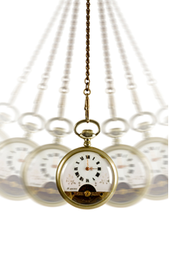
 | Due:

In groups of 3, plan and conduct the following investigation:
Determine the effect of one of the following factors on the time taken for a pendulum swing: length of pendulum, height of pendulum drop, mass of pendulum …
Individually, write a laboratory report for the experiment.
 |  | Mark Allocation | Mark
Introduction | - Review of current scientific knowledge  - Background information | 2
Aim and Hypothesis | - Aim is clear and concise  - Hypothesis relates independent and dependent variables | 2
Equipment and Procedure | - Procedure is detailed and specific  - Diagram is scientific, neat, labelled, captioned and appropriately sized  - Safety and ethics considered | 3
Variables | - Independent variable is numerical, incremental and includes units of measurement.  - Dependant variable is clear and includes units of measurement  - 3 controlled variables identified  - 1 uncontrolled variable identified | 4
Results | - Table includes title which relates variables  - Columns relate to independent and dependent variables and include headings with units  - Repeat trials or replicates, averages | 3
Graph | - Graph title relates variables  - Graph type appropriate for data  - Axis correct orientation and labelled, including units  - Appropriate size and scale | 4
Discussion | - Results summarised and patterns identified  - Explanation of results using scientific knowledge and terminology  - 3 sources of error or inaccuracy identified  - Specific suggestions for improvement or further experimentation | 4
Conclusion | - Summary of findings  - Hypothesis supported or not | 2
References | - At least 2, in correct format | 1
 |  | Total /25

